**Bright Coffee Shop**

Have been provided with a datasets titled “Bright Coffee Shop Sales”, which captures daily transaction information from a coffee shop.

The business has recently appointed a new CEO whose mission is to grow the company’s revenue and improve product performance.

Your role, as a Junior Data Analyst, is to extract actionable insights from historical data and prepare a presentation to assist the CEO in decision-making.

Syntax for Minimum Time when Transactions occur

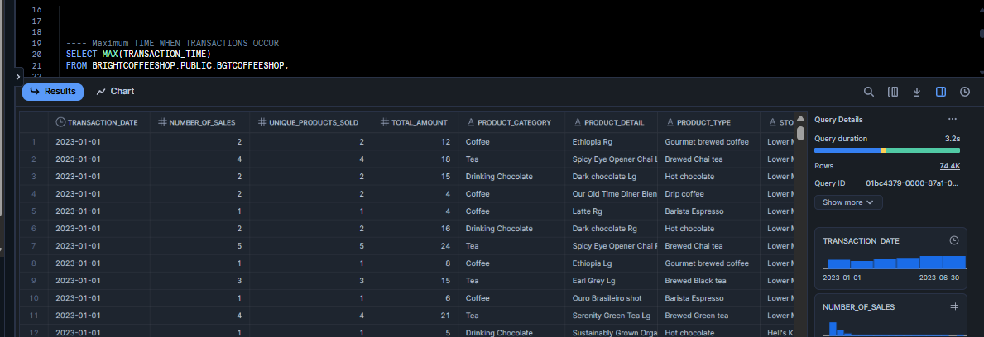

Syntax for Maximum Time when Transactions occur

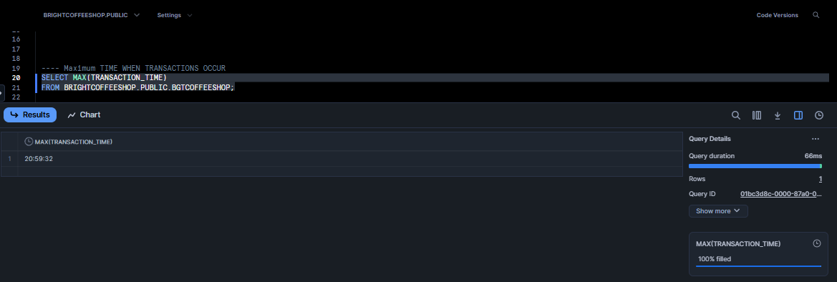

----TIME BUCKET PER HOUR, MORNING, AFTERNOON, EVENING

--- TIME BUCKETS ON HOURLY INTERVALS

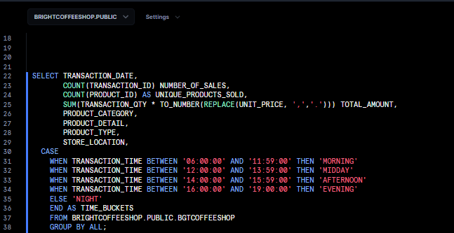

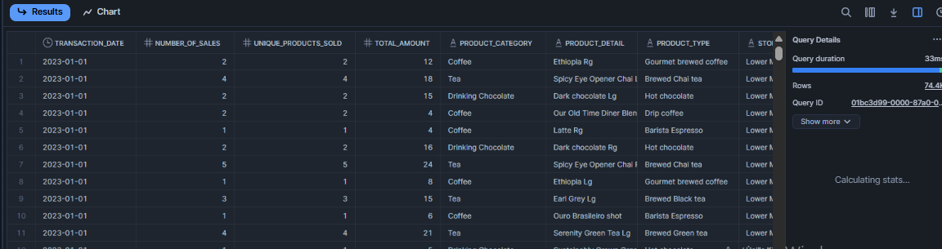

Identify Slow Time Slots

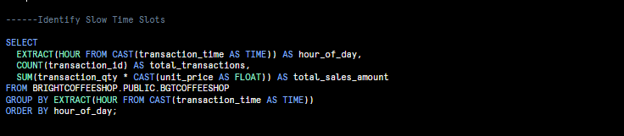

OUTPUT

